IIT (Introduction to Information Technology)

Computer is an electronic device which can work under the given instructions or commands, that takes data as its Input, process the data and gives the information to the user as its output, is called computer.
The word computer has been taken from a “Latin” word compute, which means “Calculate”.
Data: Data is the collection of raw facts and figures e.g.
- Text (Alphabets, Special Characters, Numbers etc.)
- Images
- Sound
Information: Information is the processed form of data, or we can say that it is the useful work done by the computer for its user.
Processing: The conversion of data into information by applying different types of calculations is called processing.
Input: It is the data we give to the computer.
Output: it is the useful information given to the user.
User:
A Person who uses Computer is Called User.
Storage: It is the place inside the computer, where data is kept temporarily or permanently. We can write into and read from the storage.
BIANARY NUMBERS
Computer doesn’t understand our language and we don’t understand computer language computer just understand binary numbers and there is a main process which calculates our language into binary language and then computer understand
Binary numbers are just (0 and 1).
Language: The way of communication is called language.
Computer language: The language which is used to communicate with the computer system in order to create the program.
Program: The set of instruction in a computer language which perform the specific task is called program.

Components of computer
IIT NOTES
1: Hardware 2: Software
Hardware:
The Touchable Parts of the computer which have any Physical or Specific shape, is called Hardware…

Kinds of Hardware
S.# | INPUT DEVICES | OUTPUT DEVICES | SYSTEM BOX | MEMORY
1 | Mouse | Monitor | Mother Board. | Primary | Secondary
2 | Keyboard | Speaker | CPU (Central Processing Unit) | ROM | Hard Disk
3 | Scanner | Printer | Sound Card | RAM | Floppy Disk
4 | Digital Camera | Plotter | Modem |  | Compact Disc
5 | Light Pen |  | LAN Card
6 | Joy Stick |  | VGA Card (Video Graphic Adapter)
7 | Mic |  | Etc

Input device: The devices through which we give input to the computer are called input devices.
Output devices: the devices through which the computer gives the information to its users are called put devices.
Processing devices: the devices that actually perform different kinds of operations on the data are called preceding devices.
Storage devices: the devices that are used to hold data temporarily or permanently are called storage devices.

Software:
A Series/set of Instructions/programs that we give to computer to perform some specific tasks, is called Software…

Kinds of Software
There are Two Kinds of Software
- System Software
- Application Software

System Software:
System Software Fulfills the System Requirements like: DOS, Windows, Linux and Drivers etc…
Operating Systems act as the interface between the application programs and the computer hardware e.g. Microsoft Windows 98, 2000 Professional, XP, 7, 8, Linux, UNIX etc.
Device Drivers are the small system software that are used for communication with a particular devices e.g. keyboard driver, Modem driver, sound card driver, etc.
Languages are used to translate the human instructions into machine instructions, in other words we can say that languages are used to build software. For example, C, C++, Visual Basic and Java etc.
System utilities are the system software, used for the maintenance of the computer system e.g. Disk, utilities, Antivirus Software, Anti-hacking program, etc.

Application Software:
Application Software Fulfills the User Requirements like: Word processers, Spreadsheet Packages, Database Software, Graphical Software, Communication Software, Entertainment Package, etc…
Word Processers facilitate the user in creating, formatting and editing the text documents e.g. Microsoft Word etc.
Spreadsheet Packages allow the user to manage tabular data at advanced level e.g.
Microsoft Excel etc.
Database Software allows us to maintain the information stored on one location and manipulate the data as required e.g. FoxPro, Microsoft Access, and SQL Server Etc.
Graphical software allows the user to create or edit the images. The best examples include Adobe Photoshop, CorelDraw, Flash, Maya, 3-D Studio Max etc.
Communication Software is used for communication purposes, like chatting, conferencing etc.
Entertainment Packages include the software that are used for the recreation of the user these include Audio, Video, Games etc.

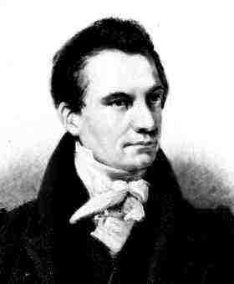
History of Computer

Father of Computer
Charles Babbage called Father of Computer.
Babbage is credited with inventing the first mechanical computer
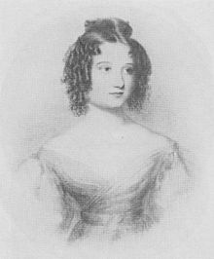
Mother of Computer
Ada Lovelace called Mother of Computer.
She is often considered the world's first computer programmer.

First Computer:-
ENIAC (Electronic Numerical Integrator and Computer) was the first fully electronic digital computer. First introduced at the University of Pennsylvania in 1946.

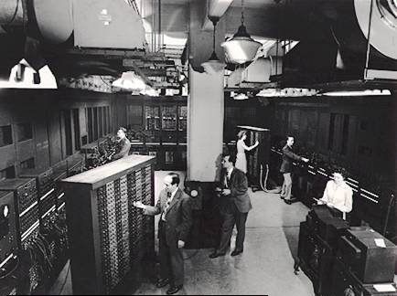
IIT NOTES

Types of Computer
IIT NOTES
There are Four Kinds of Computer
- Super Computer
- Main Frame Computer
- Mini Computer
- Micro Computer/Personal Computer
- Laptop Computer
- Hand Held Computer

Super Computers:-
- Supercomputers are the most powerful computers. They are used for problems requiring complex calculations.
- Because of their size and expense, supercomputers are relatively rare.
- Supercomputers are used by universities, government agencies, and large businesses etc…
IIT NOTES

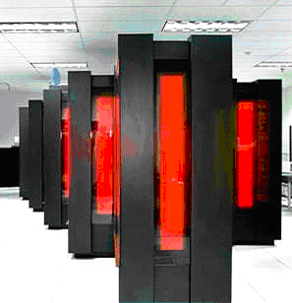
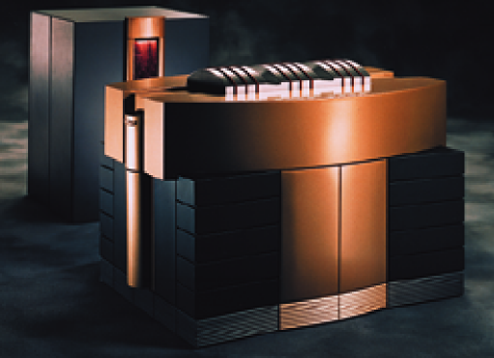
Super Computer
Cray T90 Supercomputer

Super Computer
Cray T90 Supercomputer

Main Frame Computers:
- Mainframe computers can support hundreds or thousands of users, handling massive amounts of input, output, and storage.

- Mainframe computers are used in large organizations where many users need access to shared data and programs.

- Mainframes are also used as e-commerce servers, handling transactions over the Internet.
IIT NOTES

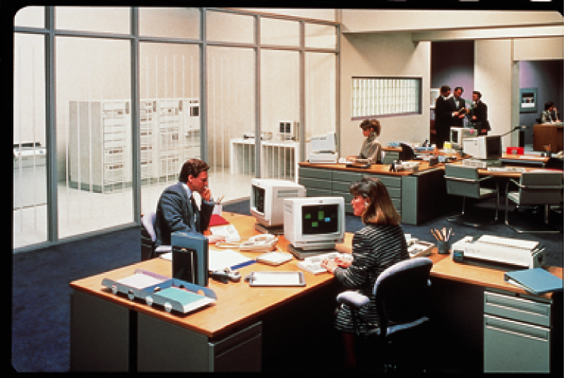

Mini Computers:
- Minicomputers are smaller than mainframes but larger than microcomputers.

- Minicomputers usually have multiple terminals.

- Minicomputers may be used as network servers and Internet servers.
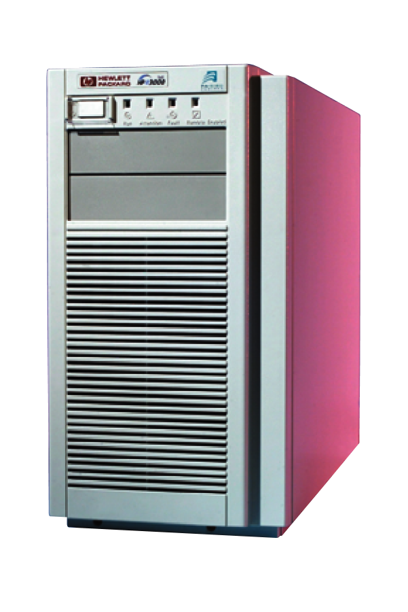
Minicomputer

Workstation Computers:
- Workstations are powerful single-user computers.

- Workstations are used for tasks that require a great deal of number-crunching power, such as product design and computer animation.

- Workstations are often used as network and Internet servers.
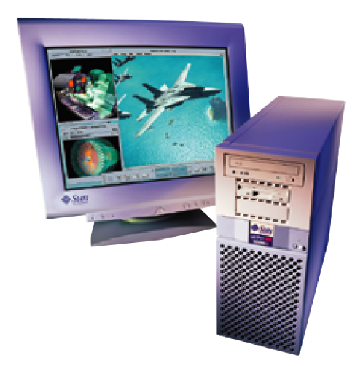
Sun Workstation

IIT NOTES
Micro/Personal Computers:
- Microcomputers are more commonly known as personal computers. The term "PC" is applied to IBM-PCs or compatible computers.

- Full-size desktop computers are the most common type of PC.

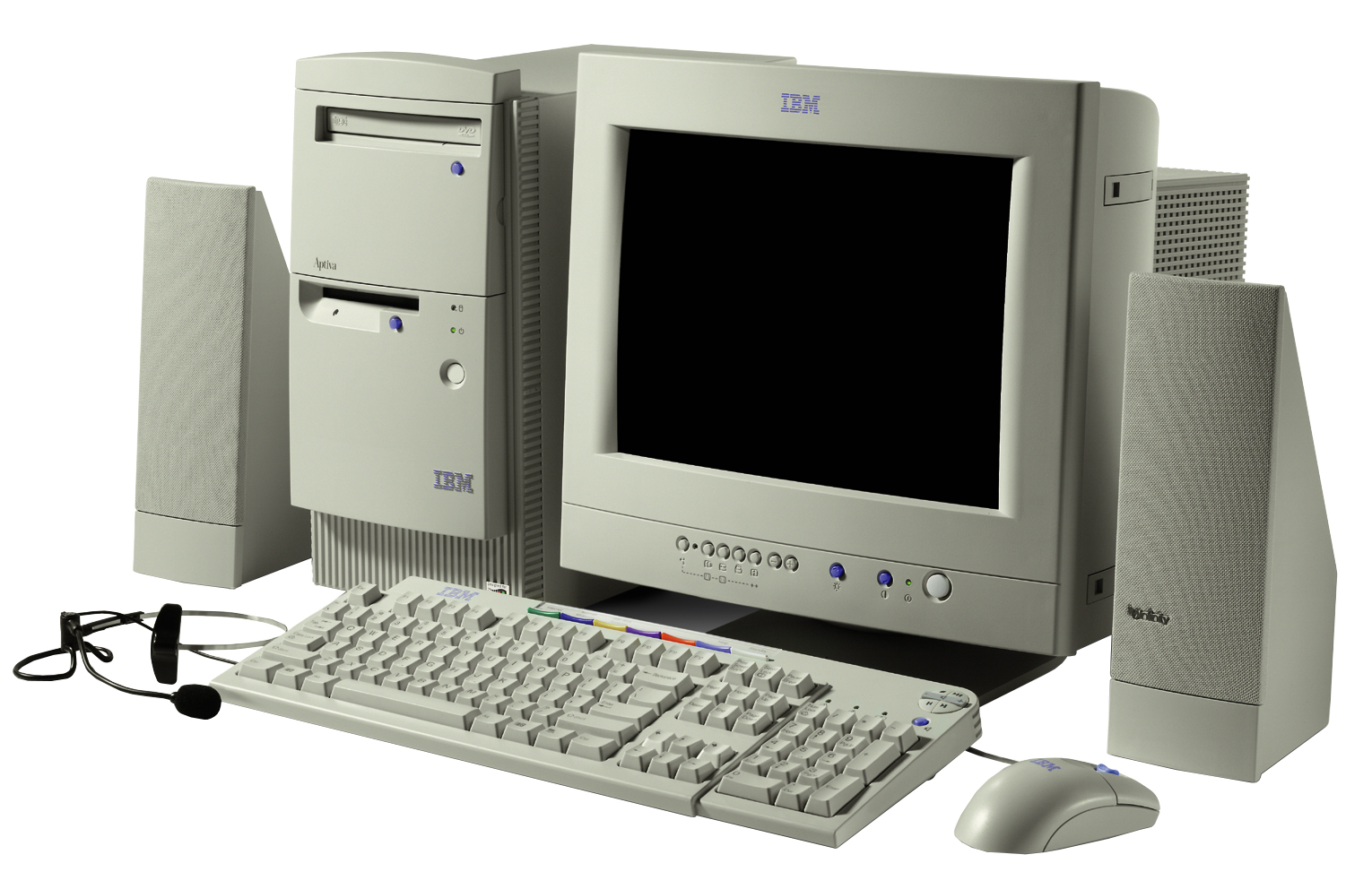

Laptop Computers: Handheld Computers:

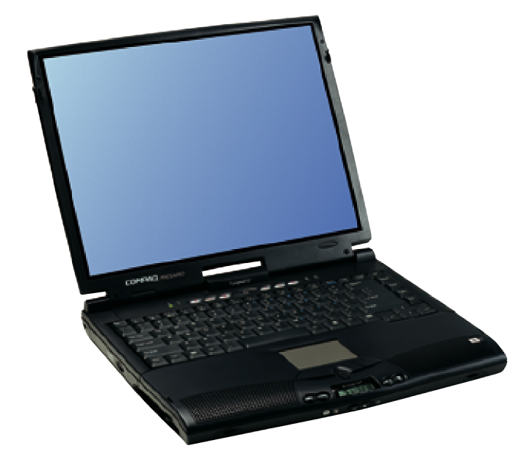
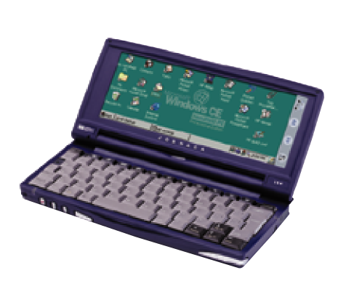
Philips Velo

IIT NOTES

